# Assignment No. 1
# Aim: Write a program to calculate Fibonacci numbers and find its step count .
# Code :
import time

def fibonacci_iter(n):
# iterative fibonacci with step counting and series generation
if n < 0:
return [], -1, 1
if n == 0:
return [0], 0, 1
if n == 1:
return [0, 1], 1, 1

steps = 0
a, b = 0, 1
series = [0, 1]

for i in range(2, n + 1):
c = a + b
a = b
b = c
series.append(c)
steps += 1

return series, series[-1], steps + 1

def fibonacci_recur_helper(n, steps):
# recursive helper to compute fibonacci value with step tracking
steps[0] += 1
if n == 0:
return 0
elif n == 1:
return 1
else:
return fibonacci_recur_helper(n - 1, steps) + fibonacci_recur_helper(n - 2, steps)

def fibonacci_recur_series(n):
# generate fibonacci series using recursion with step tracking
series = []
total_steps = 0

for i in range(n + 1):
steps = [0]
val = fibonacci_recur_helper(i, steps)
series.append(val)
total_steps += steps[0]

return series, series[-1], total_steps

# main section
if __name__ == '__main__':
n = int(input("Enter a number: "))

# iterative
start_time = time.time()
iter_series, iter_result, iter_steps = fibonacci_iter(n)
end_time = time.time()
iter_time = end_time - start_time

# recursive
start_time = time.time()
recur_series, recur_result, recur_steps = fibonacci_recur_series(n)
end_time = time.time()
recur_time = end_time - start_time

# output display
print("\n==============================")
print(" ITERATIVE APPROACH")
print("==============================")
print(f"Fibonacci Series : {iter_series}")
print(f"Fibonacci({n}) : {iter_result}")
print(f"Step Count : {iter_steps}")
print(f"Execution Time : {iter_time:.6f} seconds")

print("\n==============================")
print(" RECURSIVE APPROACH")
print("==============================")
print(f"Fibonacci Series : {recur_series}")
print(f"Fibonacci({n}) : {recur_result}")
print(f"Step Count : {recur_steps}")
print(f"Execution Time : {recur_time:.6f} seconds \n")

# Output :
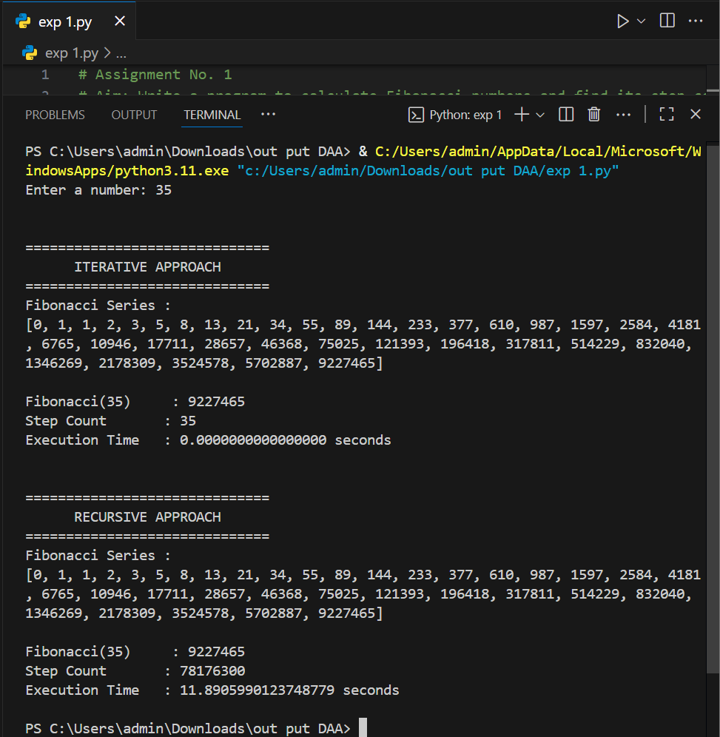
# Complexity Analysis :
Time Complexity:
Iterative: O(n), Recursive: O(2ⁿ) due to repeated subproblems.
Space Complexity:
Iterative: O(1), Recursive: O(n) for recursion stack.
# Assignment No. 2
# Aim : Write a program to implement Huffman Coding for data compression using a greedy approach.
# Code :

import heapq
import time
import argparse
from collections import Counter

# --------------------------- HUFFMAN CODING IMPLEMENTATION ---------------------------

class Node:
def __init__(self, freq, symbol, left=None, right=None):
self.freq = freq
self.symbol = symbol
self.left = left
self.right = right
self.huff = ""

def __lt__(self, other):
return self.freq < other.freq

def generate_codes(node, val="", codes=None):
if codes is None:
codes = {}
new_val = val + node.huff
if node.left:
generate_codes(node.left, new_val, codes)
if node.right:
generate_codes(node.right, new_val, codes)
if not node.left and not node.right:
codes[node.symbol] = new_val
return codes

# --------------------------- MAIN PROGRAM ---------------------------

def main():
parser = argparse.ArgumentParser(description="Huffman Coding using a greedy approach.")
parser.add_argument("file", type=str, help="Path to the input text file for Huffman encoding")
args = parser.parse_args()

print("=" * 60)
print("HUFFMAN CODING USING GREEDY APPROACH")
print("=" * 60)

# Read file content
try:
with open(args.file, "r", encoding="utf-8") as f:
text = f.read()
except FileNotFoundError:
print(f"Error: File '{args.file}' not found.")
return

if not text.strip():
print("Error: File is empty. Please provide a non-empty file.")
return

print(f"\nFile loaded successfully: {args.file}")
print(f"Total characters read: {len(text)}")

# Calculate frequency of each character
freq_counter = Counter(text)
print("\nCharacter frequencies:")
for char, freq in freq_counter.items():
print(f" {repr(char)} : {freq}")

# Start timing
start_time = time.time()

# Build Huffman tree
nodes = [Node(freq, char) for char, freq in freq_counter.items()]
heapq.heapify(nodes)

while len(nodes) > 1:
left = heapq.heappop(nodes)
right = heapq.heappop(nodes)
left.huff = "0"
right.huff = "1"
new_node = Node(left.freq + right.freq, left.symbol + right.symbol, left, right)
heapq.heappush(nodes, new_node)

# Generate Huffman codes
codes = generate_codes(nodes[0])

print("\nGenerated Huffman Codes:")
print("-" * 60)
for char, code in codes.items():
print(f"Character: {repr(char)} | Code: {code}")
print("-" * 60)

# Encode the text
encoded_text = "".join(codes[ch] for ch in text)

# Write encoded data to new file
output_file = "encoded_output.txt"
with open(output_file, "w", encoding="utf-8") as out:
out.write(encoded_text)

end_time = time.time()
print(f"\nEncoded output written to: {output_file}")
print(f"Execution Time: {(end_time - start_time):.6f} seconds")
print("=" * 60)
print("Program Execution Completed")
print("=" * 60 + "\n\n")

if __name__ == "__main__":
main()

# Input file : input.txt
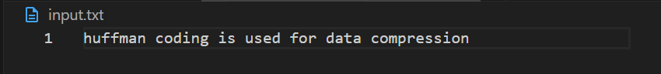

# Output : (Terminal)

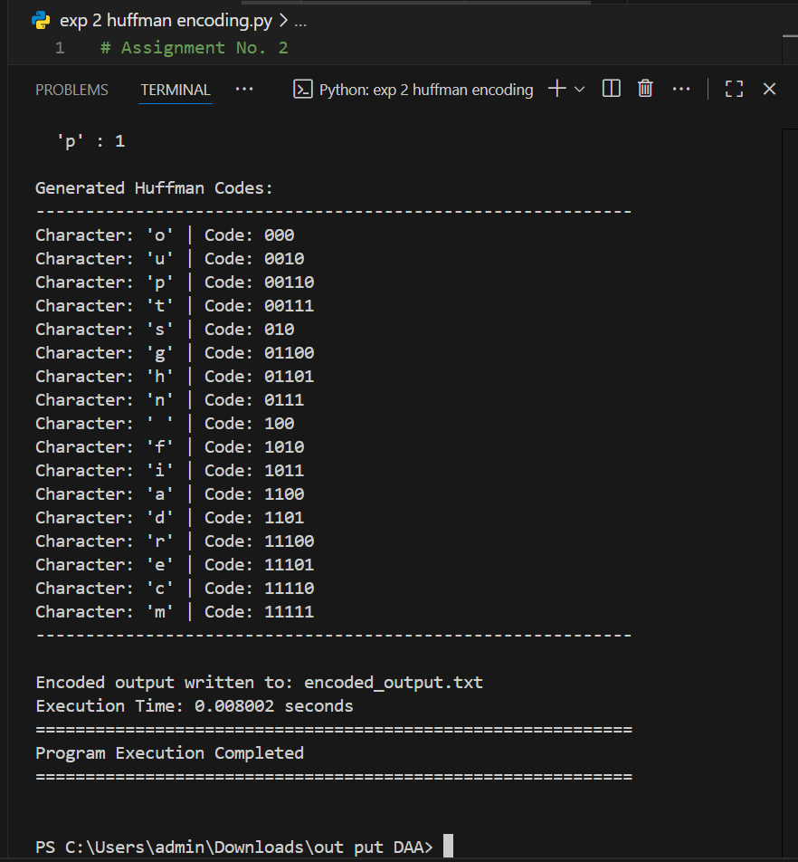

# Output file : encoded_output.txt
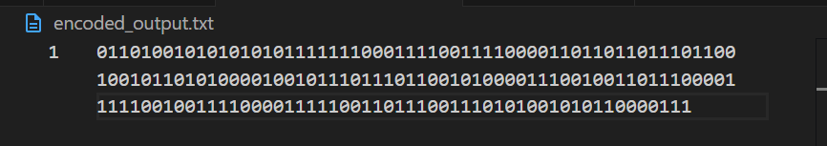
# Complexity Analysis :
Time Complexity:

O(n log n) for building the Huffman tree using a min-heap.

Space Complexity:

O(n) for storing nodes and Huffman codes.

# Assignment No. 2
# Aim: Implement Job Sequencing with Deadlines using a Greedy Method.
# Code :
import time

# structure for job details
class Job:
def __init__(self, job_id, profit, deadline):
self.job_id = job_id
self.profit = profit
self.deadline = deadline

# function to schedule jobs using greedy approach
def job_sequencing(jobs):
# sort jobs in descending order of profit
jobs.sort(key=lambda x: x.profit, reverse=True)

max_deadline = max(job.deadline for job in jobs)
slots = [-1] * (max_deadline + 1)
total_profit = 0
allocation = {}

# try to assign each job to the latest available slot before its deadline
for job in jobs:
for t in range(job.deadline, 0, -1):
if slots[t] == -1:
slots[t] = job.job_id
total_profit += job.profit
allocation[t] = job.job_id
break

job_sequence = [slot for slot in slots if slot != -1]
return job_sequence, total_profit, allocation

# main section
if __name__ == '__main__':
print("\n==============================")
print(" JOB SEQUENCING (GREEDY)")
print("==============================")

# input section
n = int(input("Enter number of jobs: "))
jobs = []
for i in range(n):
job_id = input(f"\nEnter Job ID {i+1}: ")
profit = int(input("Enter Profit: "))
deadline = int(input("Enter Deadline: "))
jobs.append(Job(job_id, profit, deadline))

# measure execution time
start_time = time.time()
sequence, total_profit, allocation = job_sequencing(jobs)
end_time = time.time()
exec_time = end_time - start_time

# display job table
print("\n==============================")
print(" JOB DETAILS")
print("==============================")
print(f"{'Job ID':<10}{'Profit':<10}{'Deadline':<10}")
print("-" * 30)
for job in jobs:
print(f"{job.job_id:<10}{job.profit:<10}{job.deadline:<10}")

# display slot allocation
print("\n==============================")
print(" SLOT ALLOCATION")
print("==============================")
for slot in sorted(allocation.keys()):
print(f"Slot {slot} → Job {allocation[slot]}")

# display final results
print("\n==============================")
print(" FINAL RESULTS")
print("==============================")
print(f"Scheduled Jobs : {sequence}")
print(f"Total Profit : {total_profit}")
print(f"Execution Time : {exec_time:.16f} seconds \n")

# Output :
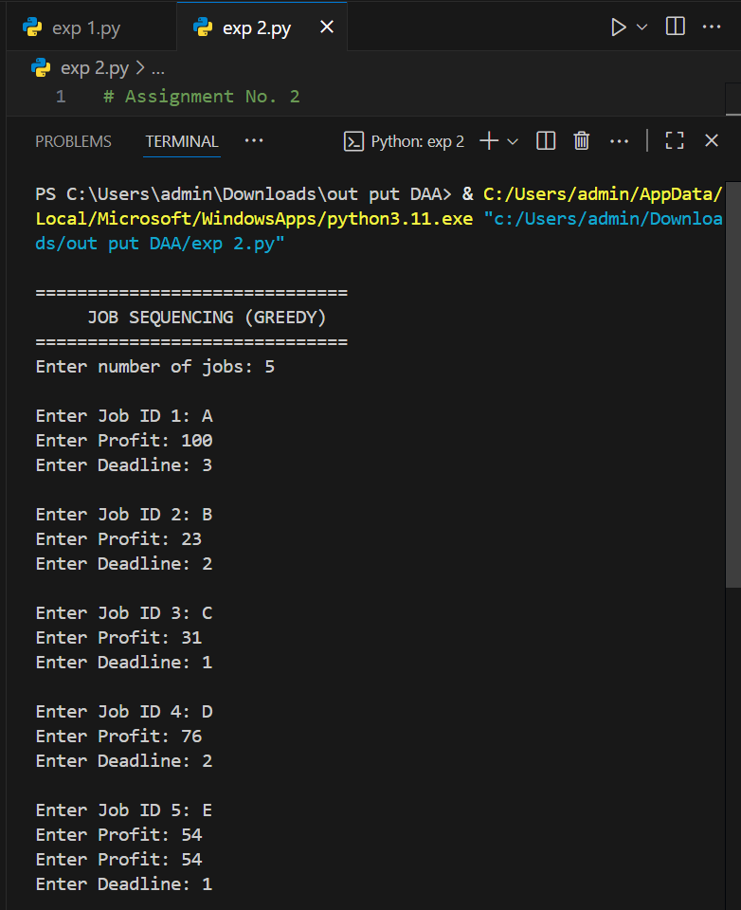

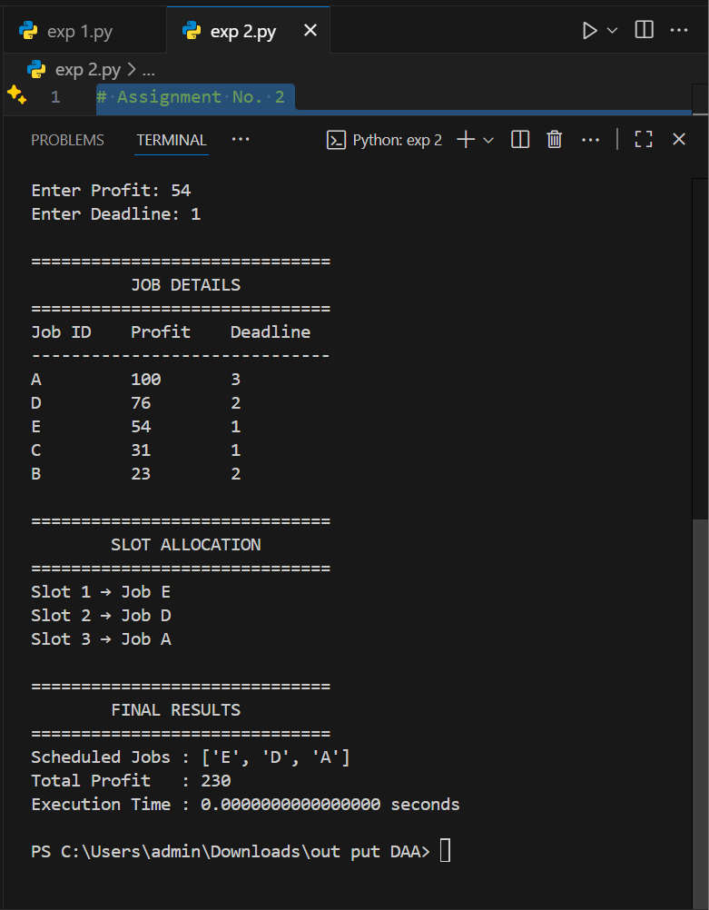

# Complexity Analysis :
Time Complexity:
O(n²) in the worst case (sorting + slot allocation).
Space Complexity:
O(n) for job list and slot tracking.

# Assignment No. 3
# Aim: Write a program to solve a Fractional Knapsack problem using a Greedy Method.
# Code :

import time

class Item:
def __init__(self, profit, weight):
self.profit = profit
self.weight = weight
self.ratio = profit / weight

def fractional_knapsack(capacity, items):
# sort items by decreasing profit/weight ratio
items.sort(key=lambda x: x.ratio, reverse=True)

total_value = 0.0
remaining_capacity = capacity
selection = []

for item in items:
if remaining_capacity == 0:
break

if item.weight <= remaining_capacity:
# take full item
total_value += item.profit
remaining_capacity -= item.weight
selection.append((item, 1.0)) # 100% taken
else:
# take fraction of item
fraction = remaining_capacity / item.weight
total_value += item.profit * fraction
selection.append((item, fraction))
remaining_capacity = 0 # knapsack full

return total_value, selection

# main section
if __name__ == "__main__":
print("\n==============================")
print(" FRACTIONAL KNAPSACK (GREEDY)")
print("==============================")

n = int(input("Enter number of items: "))
items = []
for i in range(n):
profit = float(input(f"\nEnter Profit of item {i+1}: "))
weight = float(input("Enter Weight: "))
items.append(Item(profit, weight))

capacity = float(input("\nEnter Capacity of Knapsack: "))

# measure execution time
start_time = time.time()
max_value, selection = fractional_knapsack(capacity, items)
end_time = time.time()
exec_time = end_time - start_time

# display sorted items table
print("\n==============================")
print(" ITEM DETAILS (Sorted by Ratio)")
print("==============================")
print(f"{'Item':<8}{'Profit':<10}{'Weight':<10}{'Ratio':<10}")
print("-" * 40)
for idx, item in enumerate(items, start=1):
print(f"{idx:<8}{item.profit:<10}{item.weight:<10}{item.ratio:<10.2f}")

# display selection
print("\n==============================")
print(" ITEMS SELECTED IN BAG")
print("==============================")
print(f"{'Item':<8}{'Fraction Taken':<15}{'Profit Added':<15}")
print("-" * 45)
for sel in selection:
item, frac = sel
profit_added = item.profit * frac
print(f"{items.index(item)+1:<8}{frac*100:<15.2f}{profit_added:<15.2f}")

# final result
print("\n==============================")
print(" FINAL RESULTS")
print("==============================")
print(f"Maximum Profit : {max_value:.2f}")
print(f"Execution Time : {exec_time:.16f} seconds \n")

# Output :
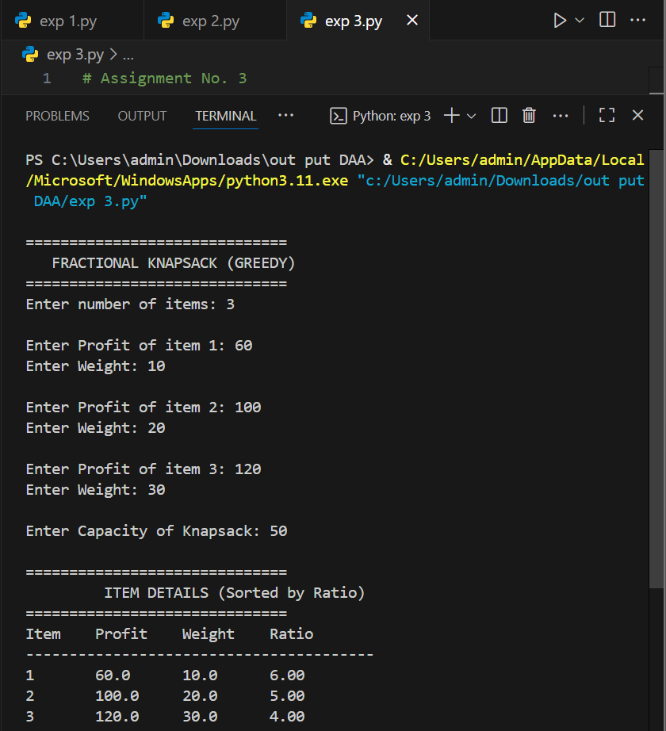

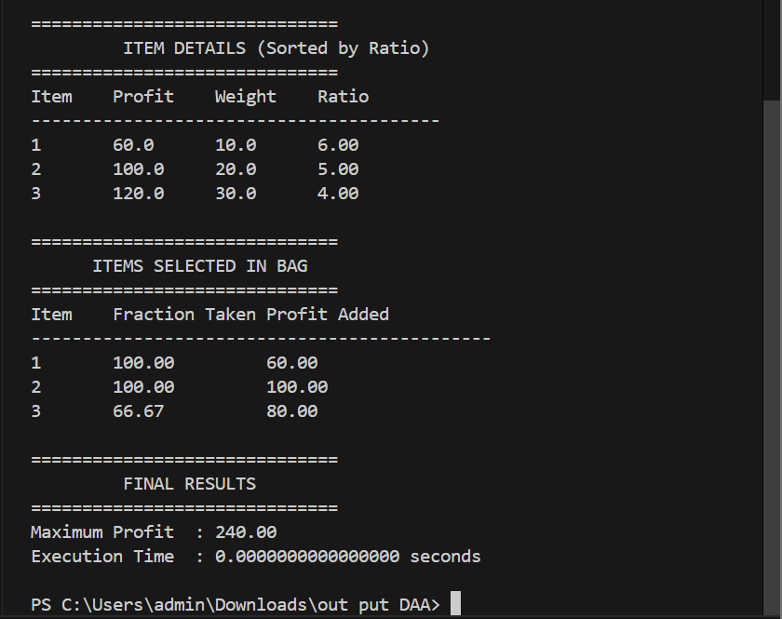

# Complexity Analysis :
Time Complexity:

O(n log n) for sorting by profit-to-weight ratio.
Space Complexity:

O(n) for storing item details and fractions.

# Assignment No. 4
# Aim: Write a program to solve a 0-1 Knapsack problem using dynamic programming or branch and bound strategy.
# Code :

import time

# function to solve 0-1 knapsack using dynamic programming
def knapsack_01(n, values, weights, W):
dp = [[0] * (W + 1) for _ in range(n + 1)]

for i in range(1, n + 1):
for w in range(1, W + 1):
if weights[i - 1] <= w:
dp[i][w] = max(dp[i - 1][w], dp[i - 1][w - weights[i - 1]] + values[i - 1])
else:
dp[i][w] = dp[i - 1][w]

# trace back selected items
selected_items = []
i, w = n, W
while i > 0 and w > 0:
if dp[i][w] != dp[i - 1][w]:
selected_items.append(i - 1)
w -= weights[i - 1]
i -= 1

selected_items.reverse()
return dp[n][W], selected_items

# main code
if __name__ == "__main__":
print("\n" + "="*50)
print(" 0-1 KNAPSACK PROBLEM USING DYNAMIC PROGRAMMING")
print("="*50 + "\n")

n = int(input("Enter number of items: "))
values = []
weights = []

for i in range(n):
print(f"\nItem {i+1}:")
values.append(int(input(" → Enter profit/value: ")))
weights.append(int(input(" → Enter weight: ")))

W = int(input("\nEnter capacity of knapsack: "))

print("\n" + "-"*50)
print("Processing...\n")

start_time = time.time()
max_value, selected_items = knapsack_01(n, values, weights, W)
end_time = time.time()

# display results
print(" Items considered:")
for i in range(n):
print(f" Item {i+1}: Profit = {values[i]}, Weight = {weights[i]}")

print("\n Items selected:")
for i in selected_items:
print(f" Item {i+1} (Profit = {values[i]}, Weight = {weights[i]})")

print("\n Maximum value that can be obtained:", max_value)
print(f" Execution Time: {(end_time - start_time):.16f} seconds")
print("-"*50 + "\n")

# Output :

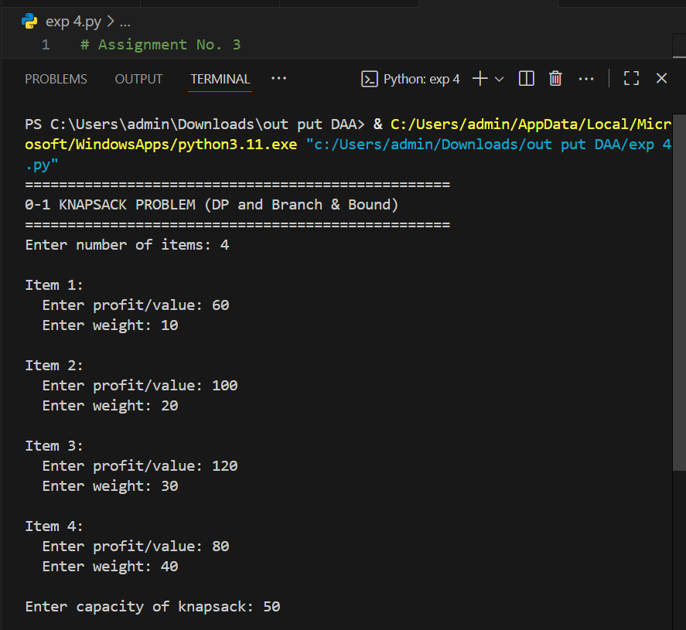
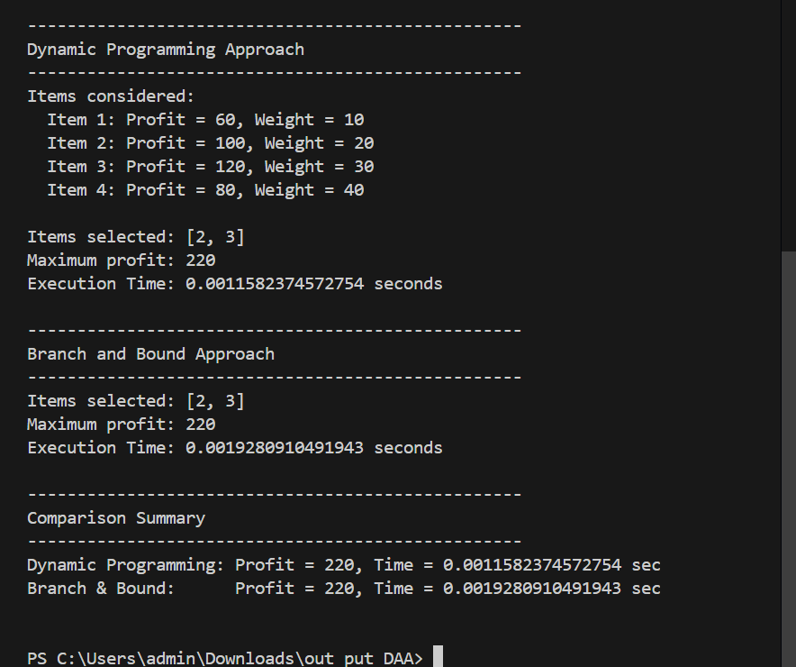
# Complexity Analysis :
Time Complexity:
O(n × W), where W is the knapsack capacity.
Space Complexity:
O(n × W) for the DP table.

# Assignment No : 6
# Aim : Design 8-Queens matrix having first Queen placed. Use backtracking to place remaining Queens to generate the final 8-queen’s matrix.
# Code :

import time

def solveNQueens(n: int, first_queen_col: int):
col = set()
posDiag = set()
negDiag = set()

res = []
board = [["."] * n for _ in range(n)]

def backtrack(r):
if r == n:
res.append(["".join(row) for row in board])
return

for c in range(n):
if c in col or (r + c) in posDiag or (r - c) in negDiag:
continue

col.add(c)
posDiag.add(r + c)
negDiag.add(r - c)
board[r][c] = "Q"

backtrack(r + 1)

col.remove(c)
posDiag.remove(r + c)
negDiag.remove(r - c)
board[r][c] = "."

# place first queen manually
col.add(first_queen_col)
posDiag.add(0 + first_queen_col)
negDiag.add(0 - first_queen_col)
board[0][first_queen_col] = "Q"

backtrack(1)
return res

if __name__ == "__main__":
n = 8

print('=' * 50)
print("8-Queens Problem Using Backtracking")
print('=' * 50)

first_queen_col = int(input("\nEnter the column position (0–7) for the first queen: "))
print('-' * 50)

if first_queen_col < 0 or first_queen_col >= n:
print("\nInvalid column position. Please enter a value between 0 and 7.\n")
exit(1)

print(f"\nSolving {n}-Queens problem with first queen at column {first_queen_col} :\n")

start_time = time.time()

solutions = solveNQueens(n, first_queen_col)

end_time = time.time()

if not solutions:
print("No valid solutions found for this initial queen position.")
else:
print("All Possible Solutions:\n")
for idx, board in enumerate(solutions, 1):
print(f"Solution {idx}:")
for row in board:
print(" ".join(row))
print()

print("Total Solutions Found:", len(solutions))
print(f"Execution Time: {end_time - start_time:.16f} seconds\n\n")

# Output :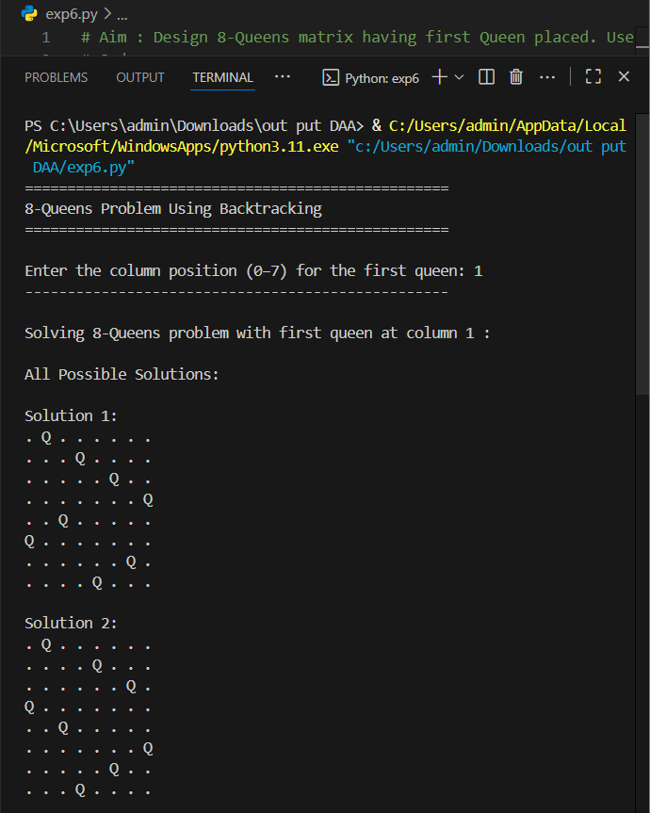
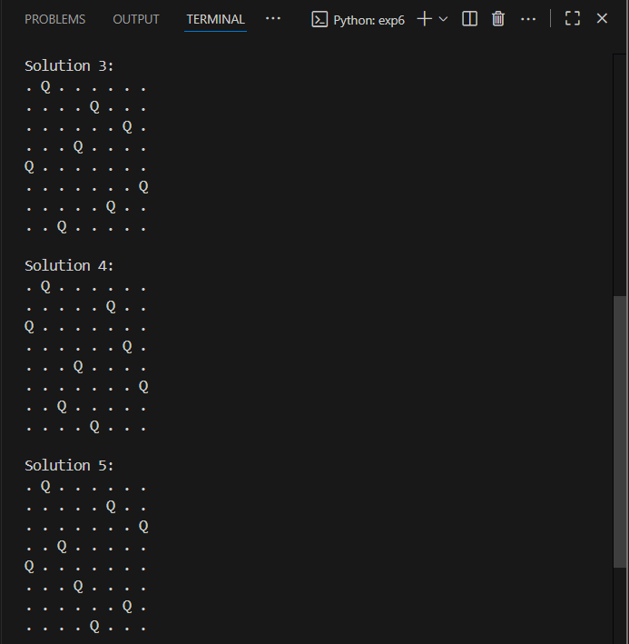
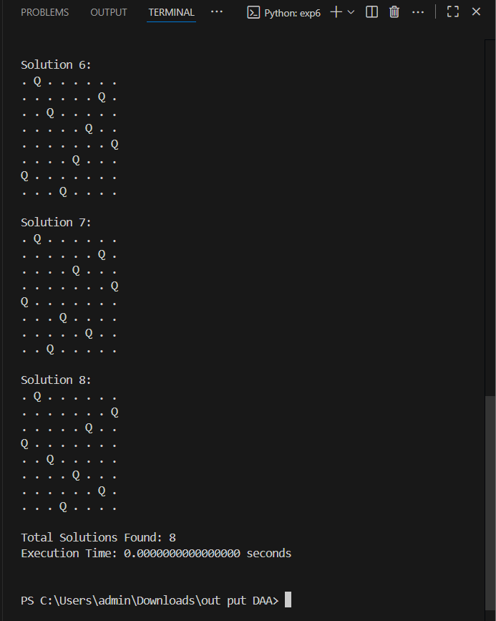

# Complexity Analysis :
Time Complexity:
O(N!) since it tries all possible queen placements.
Space Complexity:
O(N²) for storing the board and recursion stack.

